**Assignment 8.2**

**Problem Statement:**

**Write a hive UDF that implements functionality of string concat_ws(string SEP, array<string>).**

**This UDF will accept two arguments, one string and one array of string.**

**It will return a single string where all the elements of the array are separated by the SEP.**

**UDF(**StringUDF.java)

package hive.udf;

import java.util.List;

import org.apache.hadoop.hive.ql.exec.UDF;

/**

*

* This UDF will accept two arguments, one string separator and one array of

* string arrayString. It will return a single string where all the elements of

* the array are separated by the separator.

*

*

*/

public class StringUDF extends UDF {

//

public String evaluate(String separator, List<String> arrayString) {

String concatWordString = "";

for (int i = 0; i < arrayString.size(); i++) {

concatWordString = concatWordString + arrayString.get(i);

if (i + 1 != arrayString.size())//check for removal of last separator

concatWordString = concatWordString + separator;

}

return concatWordString;

}

}

**dependencies :** hive-0.4.1.jar

**created jar :** assignment8.2.jar

**Steps executed in Hive promopt**

**1.** **add jar assignment8.2.jar to hive environment**

add jar assignment8.2.jar;

**2.create temporary function with UDF class**

create temporary function stringUDF as 'hive.udf.StringUDF';

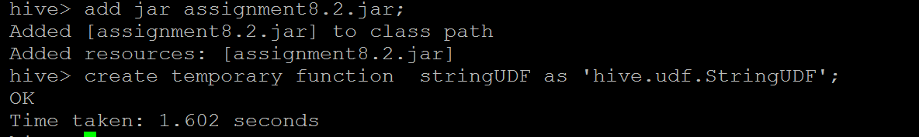

**3.Apply the UDF**

hive> select * from candidates;

OK

Ramesh 23 ["JAVA","Oracle","Spring"]

Parveen 32 ["DB2","MySQL","MongoDB"]

Time taken: 0.309 seconds, Fetched: 2 row(s)

hive> select name,age ,stringUDF('|',skills)from candidates;

OK

Ramesh 23 JAVA|Oracle|Spring|

Parveen 32 DB2|MySQL|MongoDB|

Time taken: 0.341 seconds, Fetched: 2 row(s)

